Maven

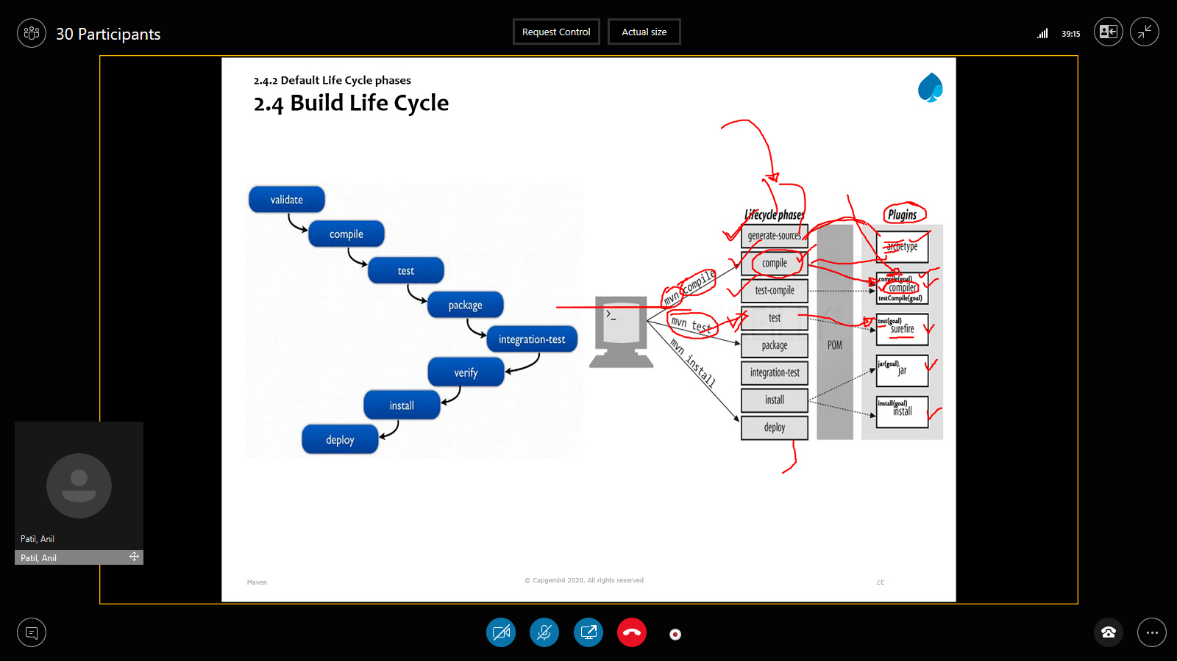

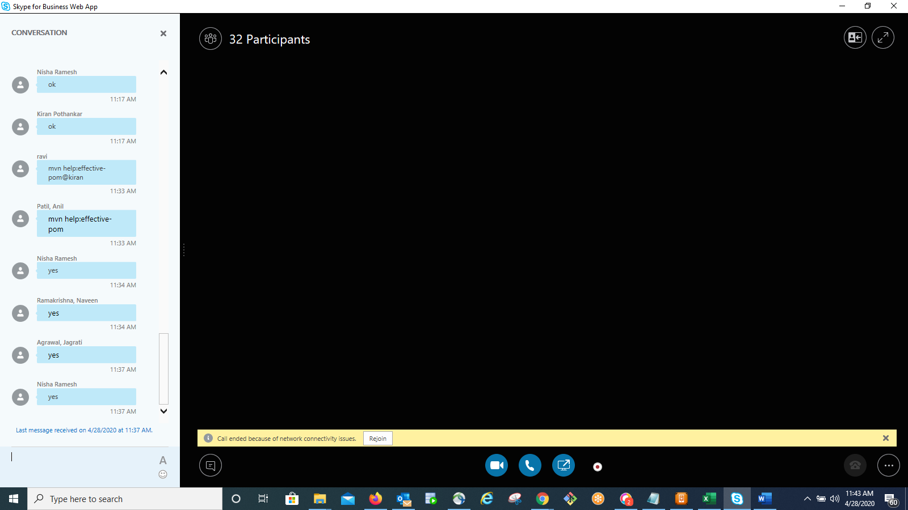

Part1 video:

<https://fts.capgemini.com/private/18739416696850/Maven28thApril2020to29thApril...-28April202009.35.38.mp4>

To download the files:

<https://fts.capgemini.com/private/61505666779323/Maven28thApril2020to29thApril...-28April202014.04.10.mp4>

Assignment:

1) Install and configure Maven and use mvn command to create

project and build it (i.e create jar file).

2) Using eclipse create a simple maven project and add

   plugin for running java class and use this plugin to

   run the java program.

3) Create simple web application using maven webapp and

   configure tomcat 7 plugin and execute tomcat7:run goal

   and access your application in the browser

4) Create simple 2 module, multimodule maven project and test

it by running mvn package command.

Part2 video:

The file(s) can be downloaded with the following URL(s):

<https://fts.capgemini.com/private/2330076621392/Maven28thApril2020to29thApril...-29April202009.38.03.mp4> link valid until 2020-05-06 7:00 UTC (SSO protected)

<https://fts.capgemini.com/private/2330076621392/Maven-Projects.zip> link valid until 2020-05-06 7:00 UTC (SSO protected)

<https://fts.capgemini.com/private/2330076621392/Maven-28042020.pdf> link